SUBMITTED BY: ASMITA JAIN

0901EO201017

**SENSOR TECHNOLOGY LAB 220202**

**EXPERIMENT - 2**

**Aim:**

**To draw the characteristics of thermocouple.**

**Theory:**Thermocouple :

A thermocouple is a junction between two different metals that produces a voltage related to a temperature difference. When two wires composed of dissimilar metals are joined at both ends and one of the ends is heated, there is a continuous current which flows in the thermoelectric circuit (the thermoelectric effect or Seebeck effect).

**Seebeck effect:**  
When two wires composed of dissimilar metals are joined at both ends and one of the ends is heated, there is a continuous current which flows in the thermoelectric circuit. German–Estonian physicist Thomas Seebeck made this discovery in 1821. This is now known as the thermoelectric effect or Seebeck effect.

**Circuit diagram:**

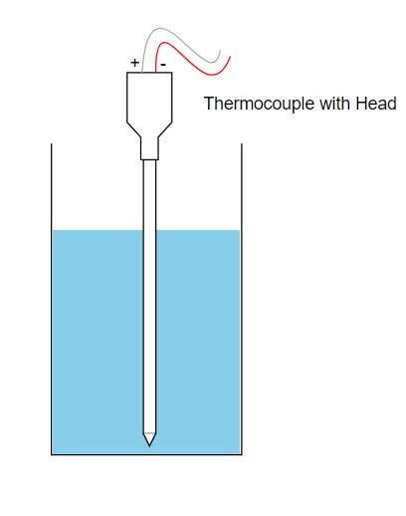

**Observation:  
  
I) J-**Type

Reference temperature: -5

|  |  |  |
| --- | --- | --- |
| **S.no.** | **Temperature** | **Output(mV)** |
| 1 | 177 | 9.94 |
| 2 | 195 | 11.01 |
| 3 | 164 | 9.71 |

**I) K-**Type

Reference temperature: 0

|  |  |  |
| --- | --- | --- |
| **S.no.** | **Temperature** | **Output(mV)** |
| 1 | 354 | 14.46 |
| 2 | 104 | 4.26 |
| 3 | 139 | 5.69 |

**Graph:**

1. **J type**

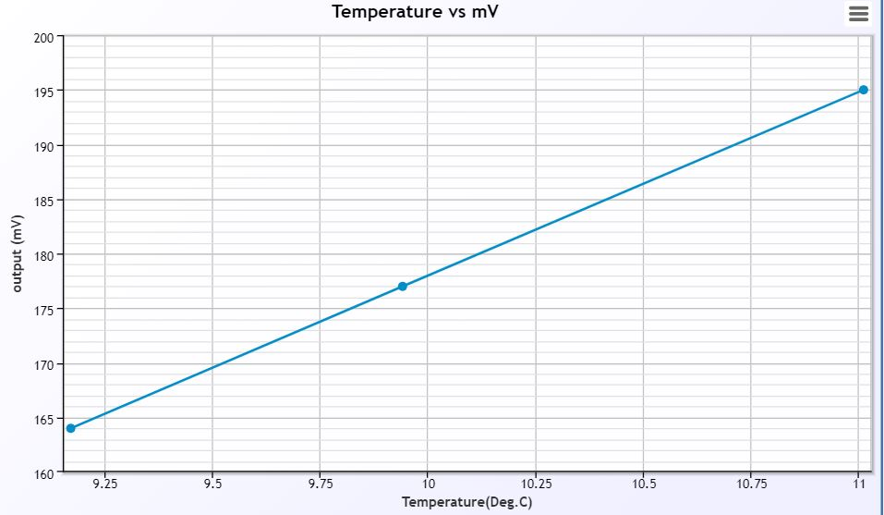

1. **K type:**

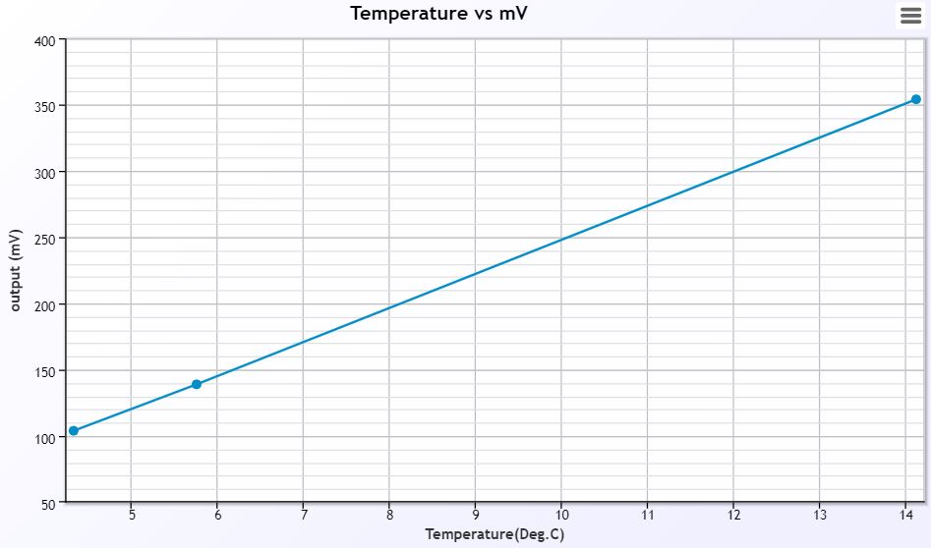

**Result:**

Principle of seebeck effect is verified.